**Tasks 2: Select, Where, Between, AND, LIKE:**

1. Write an SQL query to retrieve the names and emails of all customers.

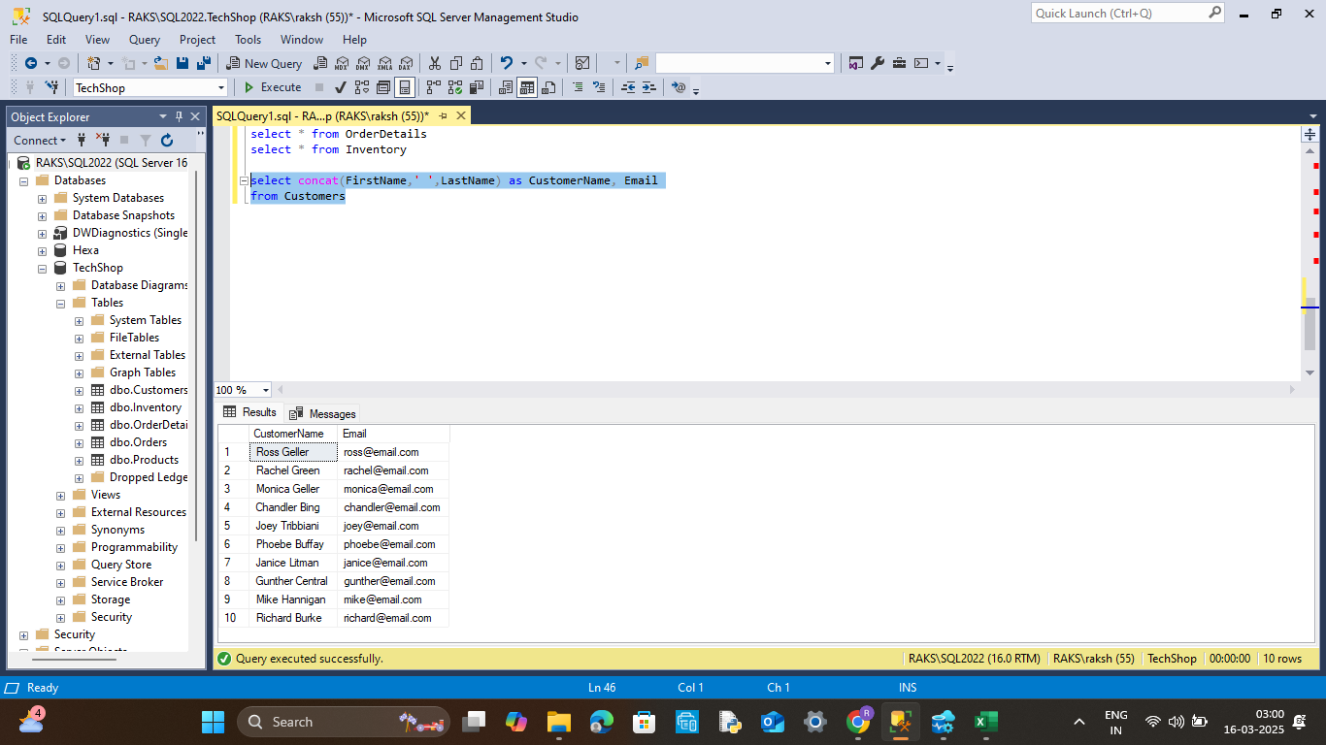

2. Write an SQL query to list all orders with their order dates and corresponding customer names.

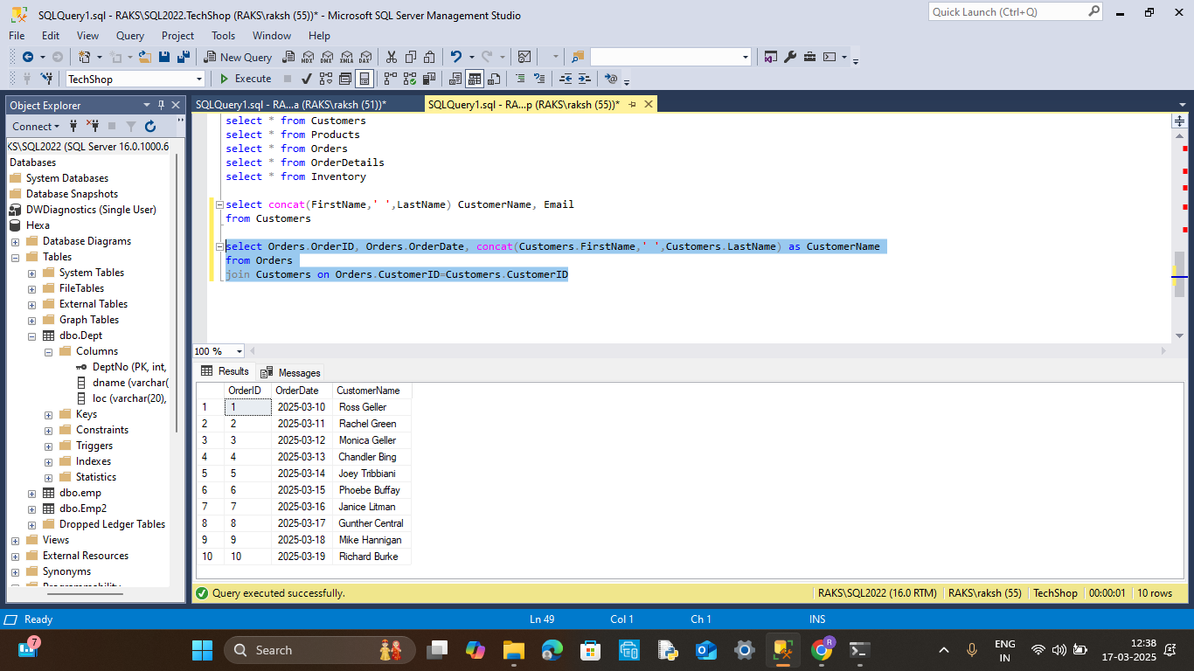

3. Write an SQL query to insert a new customer record into the "Customers" table. Include customer information such as name, email, and address.

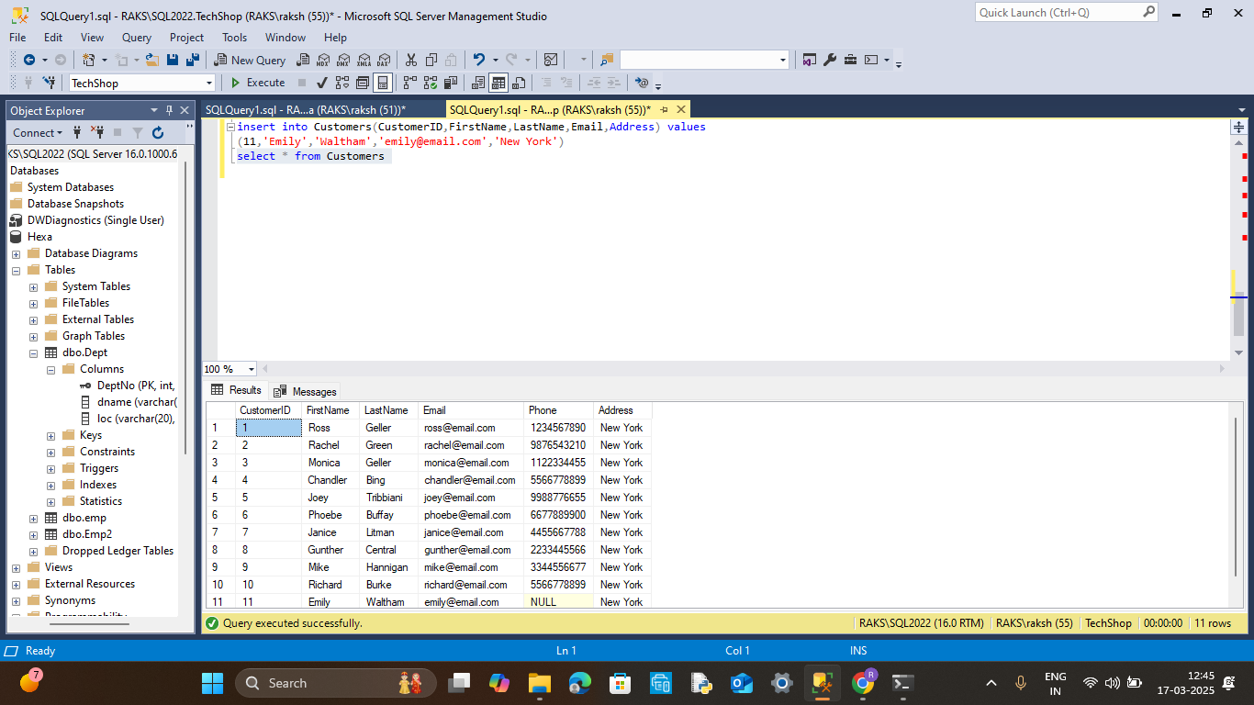

4. Write an SQL query to update the prices of all electronic gadgets in the "Products" table by increasing them by 10%.

(using update.. set)

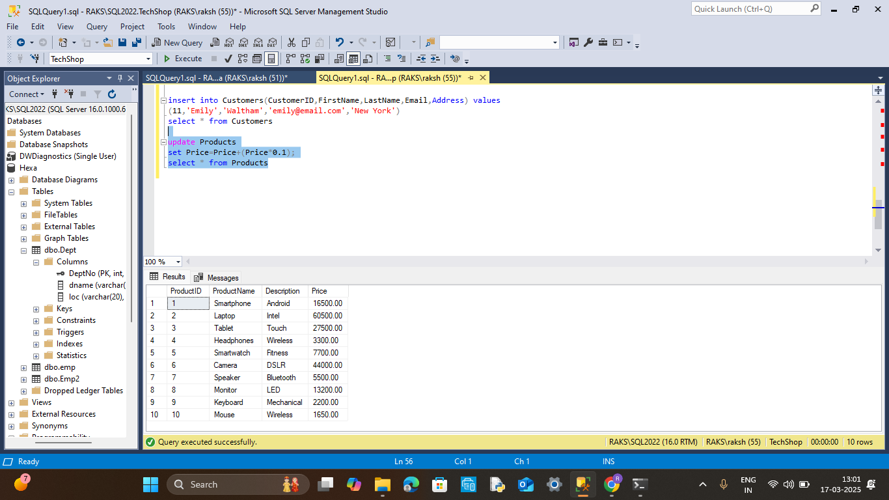

(using select)

